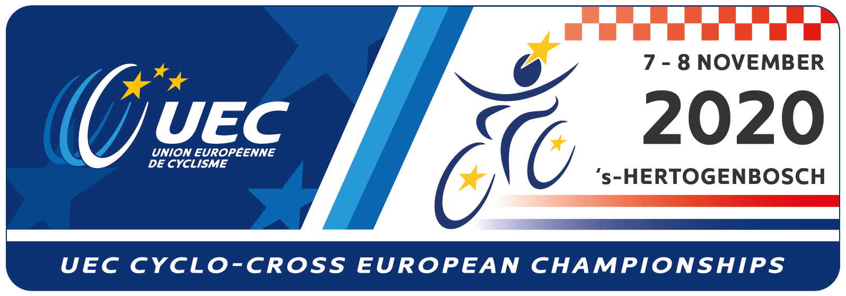

Expression of interest for participation form
Country:
 |  |  |  | Number of riders per category
Riders Category : | Men Elite
 | Women Elite
 | Men U23
 | Women U23
 | Men Junior
 | Women Junior
 | Please put an X on the appropriate boxes above
 |  |  |  | Total number of staff
Team staff :
Federation stamp and signature

NOTE:
Please be so kind to complete and return this form to the UEC e-mail mail@uec.ch
We would appreciate your form no later than Wednesday, 21 October 2020, 20:00 CET

